Assignment: Insurance Premium Calculator (Java Program)

Course: Object-Oriented Programming using Java

Assignment Title: Insurance Premium Calculator

File Name: InsurancePremiumCalculator.java

Total Marks: 20

Submission Deadline: 27 October 2025

Objective
To design and implement a Java program that calculates insurance premiums for domestic and commercial buildings based on user input, using control structures, user interaction, and modular programming concepts.

Premium Calculation Rules

🏠 Domestic / Private House
- Customers are charged:
  - 0.3% of the insured amount if it is less than $100,000
  - 0.25% of the insured amount if it is $100,000 or more
- A no-claim bonus of 10% is applied if the customer has 0 previous claims.
- Processing charge: $50

🏢 Commercial Premise
- Customers are charged:
  - 0.5% of the insured amount if it is less than $250,000
  - 0.75% of the insured amount if it is $250,000 or more
- A no-claim bonus of 15% is applied if the customer has 0 previous claims.
- Processing charge: $80

Program Requirements
- The program should allow multiple clients to be processed in one run.
- For each client:
  - Ask for Building Type (P for Private, C for Commercial)
  - Ask for Amount Insured
  - Ask for Number of Claims
  - Display a Premium Summary
- When the user chooses not to add another client, display a Session Summary.

Input Format
User type (P/C)?
Amount Insured ($)?
Number of claims?

Output Format
Premium Summary
Amount Insured = $<amount>
Number of claims = <claims>
[No claim bonus = $<bonus>]
Premium = $<premium>
At the end of the session:
Session Summary:
Number of Private clients = <count>
Total Private client Premiums collected = $<amount>
Number of Commercial clients = <count>
Total Commercial client Premiums collected = $<amount>

Example Program Run
Welcome to the Insurance Premium Calculator!

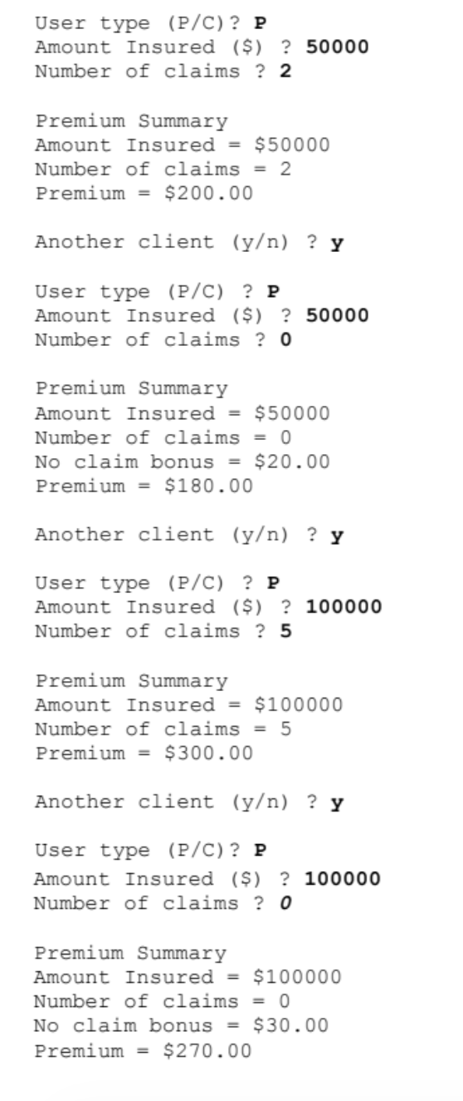
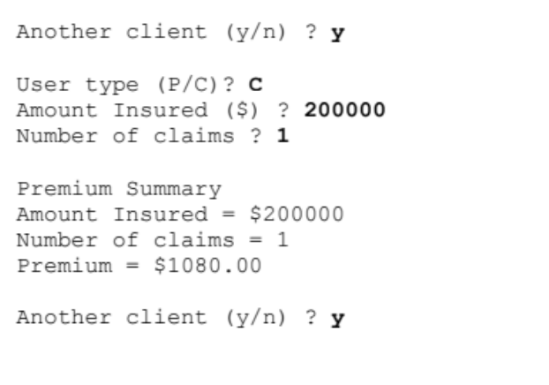
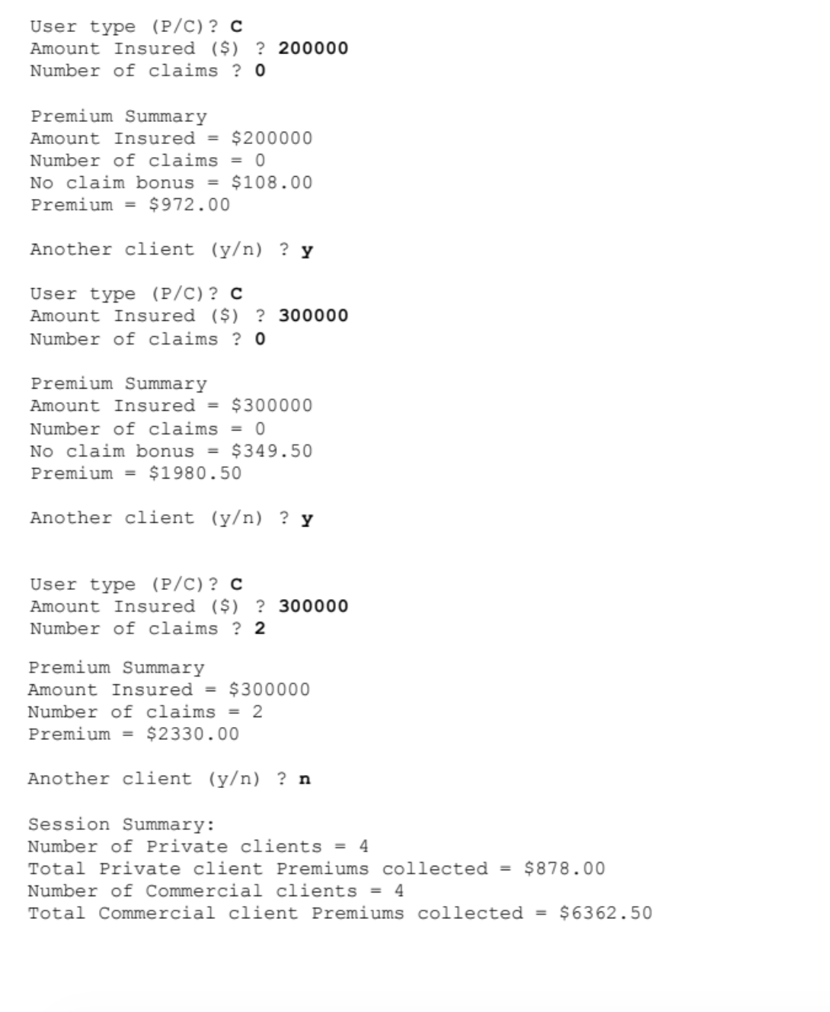

Assignment Tasks
- Implement the program logic in Java using Scanner for user input.
- Follow the exact input/output format shown.
- Handle both Private (P) and Commercial (C) clients.
- Display totals at the end of the session.
- Use functions or methods wherever appropriate (recommended for modularity).

